Inverkip & Wemyss Bay Community Council Minutes
Thursday 4 March 2024
Wemyss Bay Primary School

Attendees: Community Councillors: Dave Robinson (Chair), Frances Cassidy (Treasurer), Eileen Virtue (Secretary), Martin Armstrong.
Resident- Alastair Montgomery, Cllr Paul Cassidy, Jean Benson, .
PC. G Ross, PC. S O’Neill Community liaison officers Police Scotland.
J Adam, D Handie Community Wardens Service.
C McLellan, N Bradley Inverclyde Community Learning & Development Team.
B Dunsmore Inverclyde Your Voice.

CHAIR’S WELCOME:
Dave chaired the meeting and welcomed all. No Issues raised.

APOLOGIES:
MP Ronnie Cowan, MSP Stuart MacMillan, Scot Little CC, Andrew Bell CC, Malcom MacArthur.

POLICE MATTERS AND COMMUNITY WARDENS REPORT:
Welcomed and Introduced new Community Liaison officer PC Stewart O’Neill.
Officers advised all to utilise the Police Scotland website for reporting any incidents, further advising that all emergency incidents should be reported via 999 call.
Residents are advised to ensure all incidents or concerns are reported and logged as this helps raise awareness for police divisional prioritisation of resources.
Police and wardens service rely on residents helping by them reporting concerns not just if witnessing an incident in progress but also if see groups gathering, or are worried about potential issues starting – it gives opportunity for police and wardens to head-off situations and manage them more effectively.
Everyone aware of issues with getting through on 101 line, but persist as all reports help give divisional police command accrate pictures of what /where resources need to be allocated. Inverkip & Wemyss Bay are not worst areas, and with limited resources it may be that police and wardens vans are occupied elsewhere,and not able to respond immediately.
Public can also use leave emails/messages on the Local Community Police website for local officers to pick up.
Wardens service report attached in appendix A. Fairly quiet just now in our area. Probably helped by the recent weather and not in peak holiday time yet.
Community Police and Wardens teams are engaging again this year with the Interagency Task Force planning on joint efforts to manage anticipated usual seasonal increases in youth gatherings. And there are plans as per previous years along with BT Transport Police, MSP/MP, Inverclyde pastors,etc for joint actions.(which cannot be shared here)
Dave thanked Police and Wardens on behalf of IWBCC.

At this point, Calum and Nicole from CLD took control of the Meeting
To officiate on behalf of Inverclyde Council, to formally kick off the new Community Council after the recent elections.
Agenda attached in appendix B.
CLD issued information packs to each CC member (and will ensure delivery to those not able to attend tonight)
Also invited all community councillors to welcome event hosted by Inverclyde Council at Beacon Theatre on 20 March at 7pm. (invites also being sent via email)
Election of CC office bearers:
Formally proposed (by Martin A) and seconded (by Eileen V), and unanimously agreed to elect Dave Robinson to continue as IWBCC Chairperson.
It was also agreed that we hold-over the decision/vote on other CC office bearer positions of Treasurer /Secretary until the next meeting when hopefully other CC members can be present.

Previous Minutes
Minutes for meeting on the 07/02/2024 were proposed by
Eileen and seconded by Francis.
With 1 correction to the Treasurers section, Expenditure to read web Hosting
Actions from Minutes:
Martin to take recent photos of worn road markings Langhouse Road and send to Cllr Cassidy.Done
Eileen to organise new keys for noticeboards. Done

TREASURER’S REPORT
Frances confirmed
Yearly grant received - £1212
Current balance is £4446.19 (including some funds “ringfenced” for heritage board project)
Discussed donation for Kip Fest request received:
Confirmed that it had been discussed and agreed IWBCC donate as per previous years
to Kip Fest and Wemyss Bay Gala Day – Francis will arrange funds transfers of £150 to each .

SECRETARY’S REPORT / CORRESPONDENCE

Eileen reported fairly quiet month for emails received of which all had been responded to or sent onwards to CC members.
Emails listing attached in appendix C

PLANNING MATTERS
Relating to our area some domestic home improvements, amendments to plans for homes at Seacroft, Langhouse Mews, Inverkip Main Street.
All planning applications can be viewed online at Inverclyde Council website – Planning portal
https://www.inverclyde.gov.uk/planning-and-the-environment/planning-applications/how-to-view-planning-applications/planning-online-terms-and-conditions-of-use

AOB
Covid Memorial Labyrinth Project:
Dave met on IWBCC behalf with Rig Arts & artist at proposed Inverkip & Wemyss Bay memorial site – Lunderston Bay to discuss and highlight our concerns and disappointment with the proposed location, accessibility and lack of meaningful consultation.
Concerns included location not being within or near either of our villages nor readily accessible via foot or public transport. Also no access with those with impaired mobility to get to the proposed site (within the old playpark area at Lunderston Bay). In addition not utilising local businesses in their construction(as contracted to a Paisley based firm) We had also suggested a possinle alternative location of the park area behind Wemyss Bay Community Pavilion.
Project is funded by grant from Scottish Govt independently applied for by Rig Arts - not part of planned Inverclyde Council Covid memorial project nor in partnership with them. Funding of £17K per memorial granted ,for Kilmalcolm, Gourock, Greenock, Port Glasgow and Inverkip&Wemyss Bay.
Rig Arts are applying to Inverclyde Council to request the memorials be located on Inverclyde Council owned or managed land – due to go to IC Environment & Regeneration committed next month.
As we did not feel our concerns being taken to be take onboard specifically regarding the IWB memorial plans – we discussed and decided to voice our concerns in letter to Inverclyde Council.
We are not against the project ideas, but do not feel that a memorial purporting to be for Inverkip & Wemyss Bay is located outwith our actual village areas.
Eileen as secretary to send to IC on our behalf. (Done Francis & Eileen drafted email and sent to Stuart Jamieson IC, copying our local Councillors, CC members on 15 March.)

Dementia Care – Your Voice:
Bethan Dunsmore joined us from Inverclyde Your Voice.
Explained about her role at Your Voice as part of Dementia Friendly Initiative .
She encouraged IWBCC to sign up to this initiative to champion Inverclyde as dementia friendly space – which involves asking community groups to sign up to the 5 pledges to supporting dementia sufferers in Inverclyde.
Discussed and agreed would be something IWBCC happy to be involved with.
We agreed to discuss further with Church/Hub/Community Association about hosting awareness session /fundraiser in our area.
Councillor Roundup:
Cllr Cassidy shared info below
HSCP service received Gold Award for TeleCare Digital service
Inverclyde Council(IC) working in partnership with other councils on Numeracy Program
IC grant investment of £200k to develop Coves Nature Reserve (Greenock)
IC grant investment of £110k for restoration of Customs House Clock Tower (est 1860)
IC school leavers statistics 2022/2023 96.4% into work/training/further education. 9th best council area in Scotland.
IC community funding (round 2) – Warm Hands of Friendship initiative grants to Inverkip Hub (£1500 )and Inverkip, Skelmorlie & Wemyss Bay Church (£480)
HSCP consultation budget cuts - £5.2m savings
IC disappointed on move 450 jobs out of area. Actively pursuing options with parent companies to try and encourage them to stay
Motion before IC to recognise the Inverclyde Big Beach Clean Project which is running between 5/3/2024 and 20/4/2024.
Environment & Regen Committee – approving road maintenance plan including in our area:
Millhouse Road Inverkip – resurfacing
Anchorage to Langhouse Road, Main Street Inverkip
Reserve list: WB Ardgowan Road to Caron Road , Toward and Inellan Road pavements

IC approved 2 year budget of £250m, capital reserve of £72m , funded via council reserves and potential council tax increase, saving jobs and services which were under threat.

Dunrod Road – asked Cllr Cassidy if any updates:
Confirmed £2.3m funding for reconstruction project is in place
Hopefully outlook work to start later in 2024

IWBCC Twitter account – Martin agreed to set up and monitor on our behalf

Next meeting 7pm 04/04/2024 @ Inverkip Primary School.(rear entrance)

Appendix A:
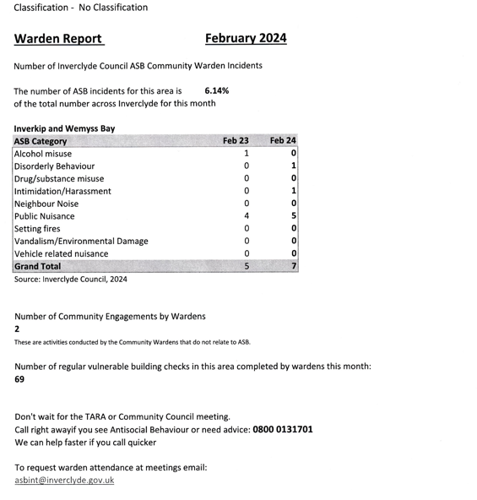

Appendix B:
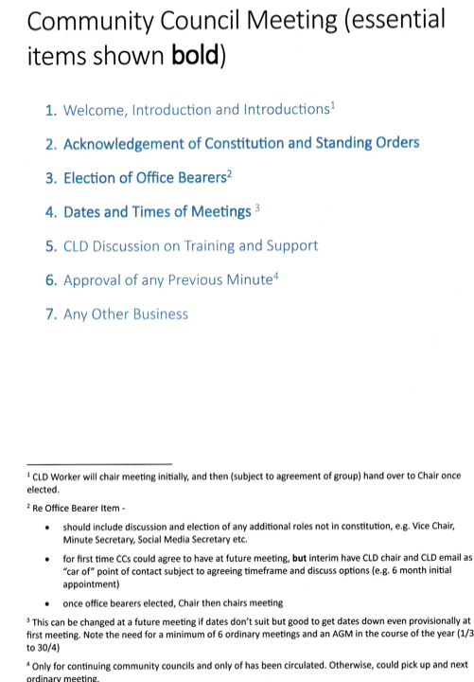

Appendix C:
Emails to mailbox
