Inverkip & Wemyss Bay Community Council (CC)
Thursday 6/08/2026
Inverkip Hub 7pm

Attendees: Community Councillors: D.Robinson (Chair), Frances Cassidy(Treasurer), Martin Armstrong(CC), Tony Sweeney(CC), Eileen Virtue (CC) ,Gaby Walsh(CC).
Cllr P. Cassidy, Cllr J Daisley, S.McMillan MSP, J. Boyd (Inclusive Communites, Inverclyde Council), J.Adam & H.Stoner (Community Wardens), J.McAdam (85th Scouts), J.Anderson, R.Kirkpatrick. M.McArthur , A.Montgomery, S,O’Donnell, I.Rennie.
APOLOGIES:
Scot Little (CC), A. Bell (CC).

CHAIR’S WELCOME:
Meeting was formally opened by Dave Robinson who welcomed all
Minutes of previous meeting were discussed and accepted. Minutes proposed by (CC Dave Robinson) and seconded by (CC Gaby Walsh).
Community Wardens
Wardens delivered report (attached) Residents thanked Wardens for attending in person, but again raised concerns that they are not able to share much info around local incidents at meetings, just statistics. We are aware that ongoing investigations/privacy concerns around what could be shared, but would appreciate info like has anyone been charged, or police involved in further investigations, etc. Cllr Cassidy agreed to bring up with Wardens service management.
Residents questions asked regarding large car been blocking footpath on Cloch Road at Gourock Road End for several weeks now, Blocks pavement meaning pedestrians with pushchairs,wheelchairs have to go around it by stepping into the road. Wardens confirmed it has been reported.
Residents are advised to call Wardens right away if they see anti-social behaviour or need advice
0800 0131701 Wardens can help faster if Residents call right away!
Community Police Report – No police in attendance tonight
Reminder - Police and Wardens rely on local residents to keep them informed – so please residents keep reporting.
Police aware that sometimes can be frustrating delays with 101 - advised try using the “contact US “ link on local police page (reports left there route to same team as 101 calls and get reported /logged in same way). .
Still use Wardens and 101, and of course if serious phone 999.
101 helps future resource planning for Police bosses.

TREASURER’S REPORT
F. Cassidy Treasurer advised the current bank balance stands at £12,781.98 as at 2/8/2026
(includes “ring fenced” funds allocated to Village projects and a donation received with thanks towards Heritage Board on Inverkip Main Street, received from Holt Leisure.)

SECRETARY’S REPORT / CORRESPONDENCE
Secretary not in attendance so no detailed report.
Emails to IWBCC , not many this month but does include:
- Concerns re-delays caused by backup of traffic queuing for the ferry at Wemyss Bay. Residents email shared with IC Cllrs, MSP, MP.
Further discussion took place during this meeting.
Wardens and Councillors confirmed no reports of any emergency vehicles issues with access or passage reported.
Stuart McMillan(MSP) confirmed he has been in ongoing dialogue with Calmac over WB situation. Calmac confirmed 67 vehicle parking spaces at WB pier. Approx 50 vehicles capacity per ferry but obviously can vary each sailing as to size/make-up of types of vehicles loading. . Info & instructions are shared each morning with the terminal staff regarding queuing vehicles.
Calmac undertaking is looking at automated booking system for WB and any other feasible long term solutions to the issue occurring at peak times.
Police and Calmac also due to hold meeting next week.
- Email from Inverkip resident regarding several incidents on Inverkip Main Street from a householder over last 3 months. Residents email forwarded to Community Wardens, Community Policing team, shared with IC Cllrs, MSP, MP.
Further discussion took place during this meeting.
- Invite received to AICC (Association of Inverclyde CC’s) next meeting and AGM Thursday 13 August at 7pm Greenock Town Hall(Saloon).
- Invite received to West Locality Planning Group Monday 17 August at 10am at Broomhill Gardens & Community Hub. Agenda to include Review/agreeing updated Terms of Reference, Clarifying purpose of localities and role of members, Agreeing how meetings will operate going forward, Discussing preferred meeting times, etc. One of early Key Priorities will be supporting the development of new Strategic Partnership Plan for HSCP(Health and Social Care Partnership) services.
- AMEY road works alerts:
A78 south of Fairlie (essential resurfacing) from Sunday 9 – 17 August (with road closures each night both directions between 8pm to 6am daily).
A78 Seamill (footpath resurfacing with single lane closures temp traffic lights) between Glenbyrde and Summerlea roads Tue 1 Sept until Sat 31 October between 9:30am and 3:30pm weekdays.
- Notice of parade application from 85th Scouts for Remembrance Sunday 8 November.

PLANNING MATTERS
All local planning matters can be reviewed at the link below.
https://www.inverclyde.gov.uk/planning-and-the-environment, email fro Resident Mr H.ritchie regarding the /planning-applications/how-to-view-planning-applications/planning-online-terms-and-conditions-of-use
USEFUL LINKS
For anyone interested in keeping track of planning applications as they are processed by the Local Authority.
Https://planningramps.uk/
Planning Democracy democratic is a community led organisation campaigning to strengthen the voice and influence of the public in the planning and development of Scotland’s Lands. The aim is to deepen democratic control and promote environmental justice.
https://planningdemocracy.org.uk
AOCB
New bus route to Upper Inverkip – 578B Hill Farm area.
SPT has confirmed new bus route will be trialled until January 2027. Residents /public need to Use it or risk Lose it. IC(Inverclyde Council) and SPT are discussing communications and article has been published in Greenock Telegraph/Inverclyde Now. SPT will add to bus stop timetables.
CC will add info to our Facebook, Website page,and on notice boards. Further info attached to these Minutes.
Service 578B will run 7 times per day, Monday to Saturday.
: from Inverkip, Glen Crescent, Glebe Road, Langhouse Road, Inverkip Main Street, A78, Spey Road, Lairds Dyke, Lochans Drive to Inverkip Station.
Return from Inverkip Station via Lochans Drive, Lairds Dyke, Spey Road, A78, Inverkip Main Street,Langhouse Road, Kirk Avenue to Upper Inverkip, Glen Crescent
General discussion on Greenock roads congestion around the major works at Bullring roundabout, Tesco, Container Way:
General discussion from residents about experiences of long delays and traffic congestion in first days of the diversion routes due to the Central Greenock project. Felt also not helped by other smaller area roadwords taking place within the diversion routes (not all IC, or Amey but also fibre cable works, pavements, traffic systems. Etc)
Cllr Cassidy will flag experiences of Container Way delays/congestion this week, due to lorries getting stuck in traffic at mini-roundabout.
Residents suggested some traffic lights (eg Bakers Brae, Morrisons, Ratho Street, Cappilow) need to be looked at for recalibrating to give more priority to the traffic on the new diversion routes rather than main A78 corridor.
Cllr Cassidy agreed to pass suggestions and concerns to Transport Scotland and IC Council Central Greenock project management.
General discussion on Greenock roads congestion around the major works at Bullring roundabout, Tesco, Container Way:
General discussion from residents about experiences of long delays and traffic congestion in first days of the diversion sightings of suspicious car later at night in area of Sainsbury car park and Inverkip Hub car park – after opening hours. Also been increased incidence of shoplifting experienced by Sainsbury.
MSP McMillan agreed to raise concerns with Police Scotland area command.
Stuart McMillan MSP shared info from his recent drive-around with AMEY roads team where various areas/concerns had been raised.
Resurfacing work at Inverkip sections (new lights to Hill Farm junction) had not been done at the time – but was scheduled. (and has now been done.)
East Hamilton Street, Greenock also scheduled for some resurfacing.
Weeding/maintenance of roadsides from Bridgend to Ardgowan Distillery was raised along with other areas outside of our local Council Ward.
Advised that some areas were not Amey controlled but some areas were Network Rail or other landowners. Also the overgrowth towards roundabout at South Street,Greenock is coming from Greenock Cemetary wall.
Residents also raised question about overgrown pavements alongside wall of Ardgowan Estate – especially on pavement from Lunderston Bay back to Inverkip on main roads.
Residents also raised that 40mph sign and a National Speed Limit sign both on same short section of A78 towards Inverkip.
Cllr Cassidy agreed to bring up with IC Roads dept.
Residents raised car on pavement in Main Street, Inverkip been there for some time. There is an IC notice attached to it, saying should be removed by 7 June 2026 or action will be taken.
Cllr Cassidy agreed to bring up with IC Roads dept.

SAINSBURY shop will be closing for refurbishment from Sat 5 September at 6pm to Fri 18 Sept 7am.
Martin CC also shared that the carpark drain cover and surface breakup problems have been logged with the landlords. Martin will share any future updates when available.

Cllr P. Cassidy Report
Cllr P. Cassidy advised the meeting:
IC exam results show improvements in pass rates from last year
IC Publications Online library has been opened on IC Website
IC Freedom of Inverclyde is being given to Regiment of Scotland with parade along Esplanade to Battery Park on 5 September
IC support has been continued for Antisocial Behaviour Initiatives
Greenock Police Station will be moving to Office building at Ladyburn, opposite Pottery Street. Initially the custodial suite will remain at current building. Planning permission will be sought by Police Scotland for addition of custody suite on the new site. Outlook is they will complete their move to the new premises by Spring 2028.
Braeside CC plan to ask IWBCC to joint meetings to discuss the AI datacenter and Battery Storage at Spango Valley, if it goes to planning stages.

Cllr J.Daisley Report
Resident of Lighthouses area, Wemyss Bay who is a powered wheelchair user, raised issue around lack of dropped curbs or access being blocked . Especial problem for them in WB when trying to travel to Coop as have to travel approx 100 metres on road to get there.
Cllr Daisley has discussed the situation with Amey and asked them to prioritise (also similar dropped curb problems in other areas not just our IWBCC area)
General discussion at meeting around lack of awareness of road users blocking dropped curbs.
WB Railway Bridge – residents reported cones and road marking on roadway – wondered if planned works?
Cllr Daisley agreed to try discuss with Amey if they have any plans.

Actions from meeting 06 /08/2026
- Martin agreed to action Smithy Court road markings to IC Roads.
Frances has logged report on IC Roads portal. Ongoing
- Jackie McLaren (for MP) will try to find out more info about the WB woodland ownership
and Martin and Scot will contact Community Land Scotland to see if they can help in tracing owner. Ongoing

- Eileen to check on My Bus info and share on IWBCC website. Ongoing
- Eileen and Frances to post 578B new bus route info on IWBCC website,Facebook,Noticeboards. DONE
- Stuart McMillan MSP to share any outcomes Amey,Calmac,Police re WB Ferry Terminal congestion
- Cllr Cassidy agreed to pass concerns,suggestions to IC Roads, Central Greenock project management, Amey
re Container Way congestion,
Inverkip 40mph&national speed limit signs,
Overgrown pavements Lunderston Bay to Gourock Road End,
Car blocking pavement Gourock Road End, and Inverkip Main Street.
- Cllr Daisley agreed to check with Amey if any roadworks planned for WB Railway Bridge area, and any updates around issue with dropped curb access WB.
Next meeting 7pm 3/09/2026 @ Inverkip Primary school

Appendix
Wardens report
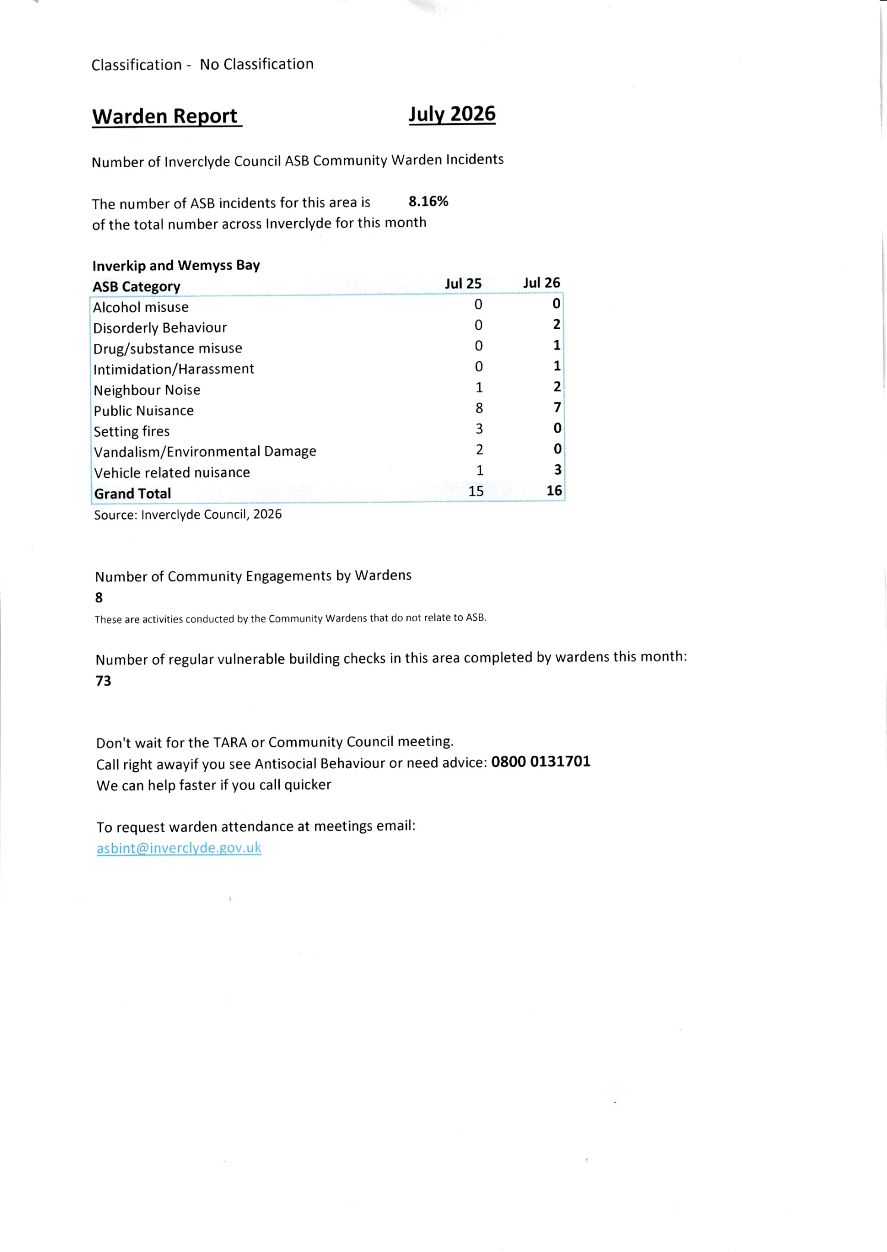

578B and 578A BUS TIMETABLE
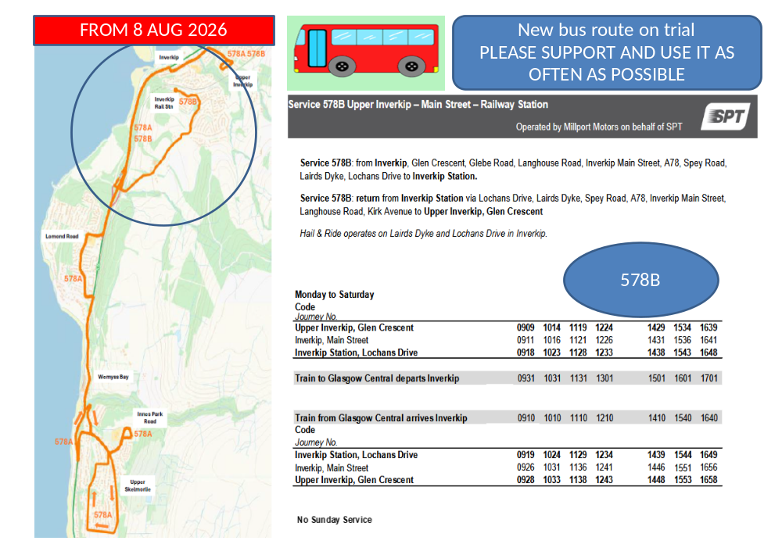
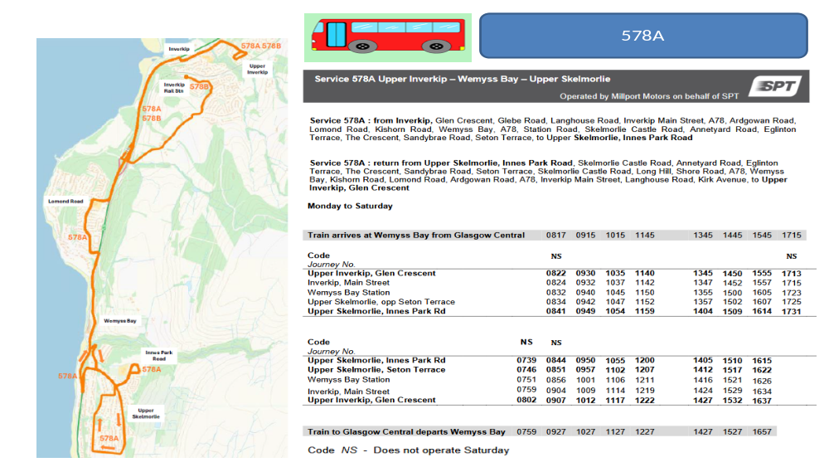

 | Inverkip and Wemyss Bay Community Council list of items for Towns & Villages Funding allocation
 | INVERKIP projects |  | Latest status
1 | Heritage information board replacement. Situated at Daff Glen park on Main Street. The original board had faded and was ripped off in storm couple of years ago. Our CC Andrew Bell has worked with graphic designer and Inverclyde Heritage group to recreate and update the information . We have a design finalised and quote for the work to create and install the board. Costings/quote attached . We have secured some donations to help with the costs from Windfarm Fund, ICE (Inverkip Community Enterprise), and Inverkip Marina and Inverkip Hotel. We are looking for £1000 to cover the balance of the costs and the planning permit required. (any excess could be used for other signage relating to local walks or returned to the fund) | 1000 | 4 June status: Update due next meeting Plans being finalised for completion and installation
2 | Bench for Daff Glen park to match the current single bench. (style Lowther to match existing bench) The seating area is popular . Part of Glasdon Quote attached. | 807.64 | Completed INSTALLED 5 May
3 | Planters (including compost & plants) -sited them at Sainsbury's , Nursery, Main Street. We worked with support of Blooming Inverkip in creating and installing some planters which have been very well received by village residents. Blooming Inverkip gardening group is engaged to help maintain the planters. | 300 | Completed
3 | Planters (including compost & plants) - initially propose siting them Inverkip Daff Glen park , Footbridge over A78 entrance Main Street and exit other side at entrance Kip Marina Village. Blooming Inverkip gardening group is engaged to help maintain the planters. | 1500 | 6 Aug: Ordered first couple planters along with noticeboards. Awaiting delivery.
4 | Friendship bench to be sited at Inverkip School , working with Inverkip school pupils. Multicoloured Bench is to offer space for pupils to sit and encourage socialisation and friendships. Pupils identified a brightly coloured bench for their request. | 464.28 | 4 June : funds transferred to School CONFIRMED
5 | Along with donation towards some new school playground games and eco garden project equipment to encourage team/partner games, and active playing , for both schools. (eg Balls, Tennis equipment ,Bug hotel  Paint to get playground games drawn on the ground ,Tent/ den area  Plastic cushions to sit on,Smaller play equipment eg scoops and balls, skipping ropes, space hopper,etc. ) | 500 | 4 June : funds transferred to School CONFIRMED
6 | 3 new Notice boards . Our wooden notice boards at Cullen Crescent and Glebe Road are deteriorating after +10 years, and suffered damage in the last big storms this season. We aim to replace these two boards, with more robust versions. Plus we are discussing with Sainsbury's and landlord to site a wall mounted additional board there. The notice boards are key part of CC advertising of local events and news relating to villages. | 2024.4 | 6 Aug : Noticeboards ordered and builds in progress. Awaiting final delivery dates confirmation. IC grounds team have kindly agreed to install the boards.
7 | 85th Scouts professional BBQ | 700 | 4 June : funds transferred to Scouts CONFIRMED
 |  | 7296.32
 | Wemyss Bay items identified in discussion with Wemyss Bay Community Association.
 | Project ideas | Totals | Latest status
1 | 3 Picnic tables and 2 benches for beside/behind Wemyss Bay Community Hall. We are hoping Inverclyde Council would help us with ordering and installing them, similar to ones we did at Inverkip Hub years ago. | 3994.71 | Completed INSTALLED 5 May
2 | Notice board at front of WB Community Hall. It did have a notice board, installed similar time as Inverkp ones +10years ago..but was removed/damaged during works and is no longer there. | 634.8 | 6 Aug : Noticeboards ordered and builds in progress. Awaiting final delivery dates confirmation. IC grounds team have kindly agreed to install the boards.
3 | Planters (including compost & plants) - proposed siting them. A new Gardening volunteer group in WB being set up - which hope will work with in creating and maintaining planters | 1500 | 4 June still working on where to site . WB Community Hub not sure if replacing previous planters wanted…as no one was able to maintain them. Ongoing
4 | Donation towards Poly Tunnel (Schools choice rather than bench) to be sited at Wemyss Bay School , | 500 | 4 June : funds transferred to WB Primary School CONFIRMED
5 | Similar to Inverkip Primary - Along with donation towards some new school playground games and eco garden project equipment to encourage team/partner games, and active playing , for both schools. (eg Balls, Tennis equipment ,Bug hotel  Paint to get playground games drawn on the ground ,Tent/ den area  Plastic cushions to sit on,Smaller play equipment eg scoops and balls, skipping ropes, space hopper,etc. ) | 500 | 4 June : funds transferred to WB Primary School CONFIRMED
 |  | 7129.51

