Inverkip & Wemyss Bay Community Council (CC)
Thursday 03/09/2026
Inverkip Primary School 7pm

Attendees: Community Councillors: Dave Robinson (Chair), Frances Cassidy(Treasurer), A. Bell (CC),Tony Sweeney(CC), Eileen Virtue (CC) ,Gaby Walsh(CC).
Cllr P. Cassidy, Cllr J Daisley, J. Boyd (Inclusive Communites, Inverclyde Council), J.Brown & W.Woodman (Community Wardens), R.Kirkpatrick representing S.McMillan MSP, and residents J.Anderson, I.Rennie, J.Rafferty, S.Howe.
APOLOGIES:
Scot Little (CC), Martin Armstrong(CC), Alastair Montgomery.

CHAIR’S WELCOME:
Meeting was formally opened by Dave Robinson who welcomed all
Minutes of previous meeting were discussed and accepted. Minutes proposed by (CC Dave Robinson) and seconded by (CC Gaby Walsh).
Community Wardens
Wardens delivered report (attached) Residents thanked Wardens for attending in person. New layout of statistics report been introduced. Wardens also shared contact cards and posters for schools and youth groups, community noticeboards to clarify the laws and regulations around electric ebikes and scooters.
Question asked if statistics are tracked regarding dog fouling? Wardens explained not in their remit and suggested to contact Mark Ashcroft at IC(Inverclyde Council). Also for residents to report any incidents or sites as much as possible.
Residents are advised to call Wardens right away if they see anti-social behaviour or need advice
0800 0131701 Wardens can help faster if Residents call right away!
Community Police Report – No police in attendance tonight
Reminder - Police and Wardens rely on local residents to keep them informed – so please residents keep reporting.
Police aware that sometimes can be frustrating delays with 101 - advised try using the “contact US “ link on local police page (reports left there route to same team as 101 calls and get reported /logged in same way). .
Still use Wardens and 101, and of course if serious phone 999.
101 helps future resource planning for Police bosses.

TREASURER’S REPORT
F. Cassidy Treasurer advised the current bank balance stands at £12744.59 as at 3/9/2026
(includes “ring fenced” funds allocated to Village projects.) Outgoings this month included bank fees, website hosting charges, heritage board invoice been received.

SECRETARY’S REPORT / CORRESPONDENCE
Secretary not in attendance so no detailed report.
Emails to IWBCC , not many this month but does include:
- Emails from attendees of LBBCC (Larkfield,Branchton and Braeside CC) re notice of holding public info meeting around the Planning Application in Principle submitted for Data Center and Battery Storage to be sited at Spango Valley. Meeting at Inverclyde Academy Tue Sept 8 6:30pm. Several IWBCC members plan to attend.
Discussed and also noted that everyone can register their opinions/concerns via the IC Planning Portal (link on main IC Website). Planning aid Scotland can also help with type of comments/wording around any objections and what are valid basis of objections that planning review boards can consider as valid.
- Notice of Open Doors Day 6 September Skelmorlie & Inverkip Churches. Skelmorlie 1-3pm, Inverkip 2-4pm
- Choral Workshop being held 12 September at Greenock Lyle Kirk Friendship Circle 15 September being held Skelmorlie Church 2-4pm
- Amey /Transport Scotland – A78 Roadworks at South Fairlie extended extra night 28 Aug.
- Email shared from MSP office email of notification to Amey regarding WB collapsed wall A78 Northbound approaching WB
- Email from Cllr Cassidy re Inverkip Core path from Spey Road to WB – closed due to dangerous bridge. Posters with info have been shared on CC Social media and on noticeboards.
- Cllr Cassidy shared that Police plan to return to more Community Policing and hope to attend more meetings in future.

- Local Fire &Rescue Plan for Inverclyde Survey available for everyone to review comment on. Open until midnight on 15 October. IWBCC encourage everyone to register any concerns or options.
- The Scottish Fire and Rescue Service is seeking your views on the draft Local Fire and Rescue Plan for Inverclyde 2026.
How to Take Part
You can view the draft Plan and complete a short consultation survey using the link below:
Consultations | Scottish Fire and Rescue Service
The consultation is open until midnight on Thursday 15 October 2026.

Notices/posters have been shared on noticeboards and CC social media.

PLANNING MATTERS
All local planning matters can be reviewed at the link below.
https://www.inverclyde.gov.uk/planning-and-the-environment, email fro Resident Mr H.ritchie regarding the /planning-applications/how-to-view-planning-applications/planning-online-terms-and-conditions-of-use
USEFUL LINKS
For anyone interested in keeping track of planning applications as they are processed by the Local Authority.
Https://planningramps.uk/
Planning Democracy democratic is a community led organisation campaigning to strengthen the voice and influence of the public in the planning and development of Scotland’s Lands. The aim is to deepen democratic control and promote environmental justice.
https://planningdemocracy.org.uk
AOCB
Village funding projects – Heritage board outlook to install by end Sept. and Noticeboards/planters – supplier outlooks delivery by end Sept.
AICC (Association Inverclyde Community Councils) meeting this month, Tony and Frances represented IWBCC.
Stuart McMillan MSP has emailed Amey re Clearway & 40 mph signage confusion coming into Inverkip from Bankfoot roundabout.
Cllr Daisley has been pursuing getting hedges trimmed around signs with IC Roads and Amey re signage.
Frances shared that had received reply from IC Roads portal :
Langhouse Road from Main Street, Inverkip is on a list for consideration for budget and funding potentially for island or improvement to aid pedestrians crossing.
The lines are scheduled to be refreshed (also confirmed by Cllr Cassidy with IC Roads).
Residents concerns have been raised with Police and IC Roads depts.
Station Road Inverkip - Residents raised concerns re huge trees overhanging /overgrown along/behind fences between Inverkip School ,Riverclyde homes and Hotel. All parties believe they do not own the trees.
Cllr Cassidy agreed to contact RC Homes for clarification.

Langhouse Road potholes(Inverkip) – residents report repairs worse than before.
Cllr Cassidy confirmed IC Roads been asked to revisit and inspect.

Marina to War Memorial (Inverkip) – concerns re overgrown trees and bushes. Amey owned land.
Cllr Cassidy confirmed issue been raised with Amey (Wemyss Bay to Bankfoot A78 full length)
Public , anyone can raise concerns / report to Amey via their website portal.
Jean confirmed she will also raise report.

Cllr P. Cassidy Roundup
- Concerns from residents around congestion in Container Way and Bakers Brae have been shared with IC Roads Project teams.
- Shared dedicated email address for specific enquiries related to Central Greenock Project
- Concerns around e-bike riders raised with Police & Fire Scrutiny Panel – Police are increasing focus on tackling
- Swallow Brae Playpark – confirmed has been adopted by IC and safety inspection has taken place. All up to standard.
However land surrounding it is not IC owned – likely to be joint resident ownership. Local resident is in progress of trying to set up Residents Group to take responsibility.
(Robert Kirkpatrick confirmed also been told that a land company owns this strip of land)
- Wemyss Bay Woodland path – contractor has been assigned by IC to extend the path
- Shielhill Glen nature trail - £94k improvements completed and path now reopened.
- IC awarded positive report for HSCP (Care at Home Service)
- Scottish Govt City Deal Cabinet looking at devolving powers from Govt to local councils
- Greenock West Blackhall Street – roads dept planning some adjustments/improvements to 1-way system flow as results of feedback received
- Nominations for Pride in Inverclyde Awards – close 21 November 2026. Can visit and vote on IC website
- Business Conference held at Beacon Theatre
- Inchgreen Partnership applying to bring Marine Engineering Training Hub to Greenock. Business plan submission is being worked on now in partnership IC, West College Scotland and Strathclyde Authority. Discussions between IC and WCS to build new college facility.
- Dunrod Road – consultants on site and progressing design plan/ground investigations. IC hoping for reports back by next meeting of Env.&Regen Committee in October. Committee had agreed in principle to approve IC works if can get done within existing approved budget allocation.
Cllr J.Daisley Roundup
- Millhouse Road to Cemetery ,Inverkip – overgrowth raised with IC dept
- Pavements on Cloch Road, Bankfoot to Lunderston Bay – moss and overgrown raised with IC Dept
- Station Ave, Inverkip – pavement uneven surface and disrepair – raised with IC Roads
- Inverkip Primary – road markings faded and problems around parking at dropoff and pick up times – raised with IC Roads dept.
- Resident raised additional issue with cars parking too close to corners – causing difficulty with visibility. Cllrs confirmed on roads dept to-do list. Cllr Daisley will pursue updates.
MSP info – Robert Kirkpatrick on behalf of MSP office - As per last meeting actions
- – MSP has been in contact with Network Rail re M&S Petrol Station Greenock overgrowth. Network Rail outlook to taken action to tidy up
- Wemyss Bay ferries – MSP discussed with Calmac re actions to alleviate queuing congestion at busy times, potential to introduce pre-booking system.
- Inverkip Entrance – enquired with Amey if can improve the look with garden/flower beds
- Pre-planning application Spango Valley data center/battery storage facility – MSP personal opinions shared on his facebook page but as chair of committee will be neutral. Scottish Govt Regen Committee has requested site visit and demo on noise impacts as part of their fact finding.
- MSP copied on email received from resident concerned re- persistant flooding Wemyss Bay (bridge/COOP ) and problems getting soaked commuting to station or shop. (likely to be worsening with autumn/winter ) Councillors, Amey , MSP , MP all copied.
Cllr Cassidy confirmed also spoke to Transport Scotland, Network Rail and IC Roads aiming to arrange meeting to discuss. Hope to hear news next week on potential meeting arrangements. Will report back on outcomes.

Actions from meeting 06 /08/2026
- Martin agreed to action Smithy Court road markings to IC Roads.
Frances has logged report on IC Roads portal. Ongoing
- Jackie McLaren (for MP) will try to find out more info about the WB woodland ownership
and Martin and Scot will contact Community Land Scotland to see if they can help in tracing owner. Ongoing

- Eileen to check on My Bus info and share on IWBCC website. Ongoing
- Eileen and Frances to post 578B new bus route info on IWBCC website,Facebook,Noticeboards. DONE
- Stuart McMillan MSP to share any outcomes Amey,Calmac,Police re WB Ferry Terminal congestion Ongoing
- Cllr Cassidy agreed to pass concerns,suggestions to IC Roads, Central Greenock project management, Amey re Container Way congestion, Done
Inverkip 40mph&national speed limit signs, Done
Overgrown pavements Lunderston Bay to Gourock Road End, Done
Car blocking pavement Gourock Road End, and Inverkip Main Street. Done
- Cllr Daisley agreed to check with Amey if any roadworks planned for WB Railway Bridge area, and any updates around issue with dropped curb access WB. Done
Next meeting 7pm 22/10/2026 @ Wemyss Bay Primary school
This will include AGM at 7pm following by regular CC meeting
Wardens report
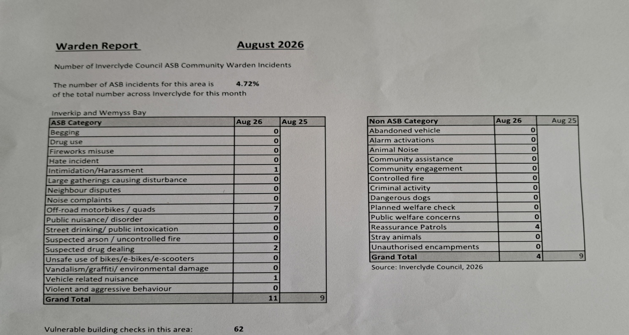

578B and 578A BUS TIMETABLE
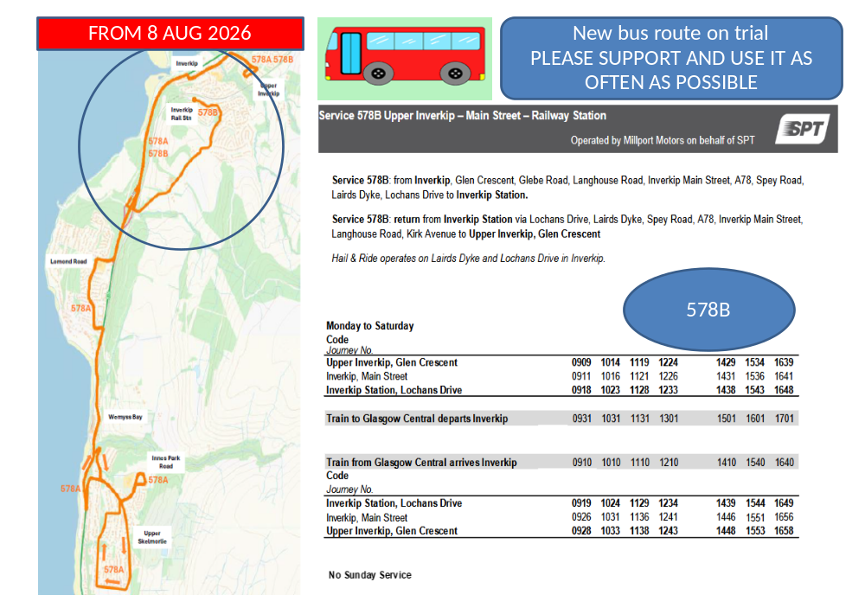
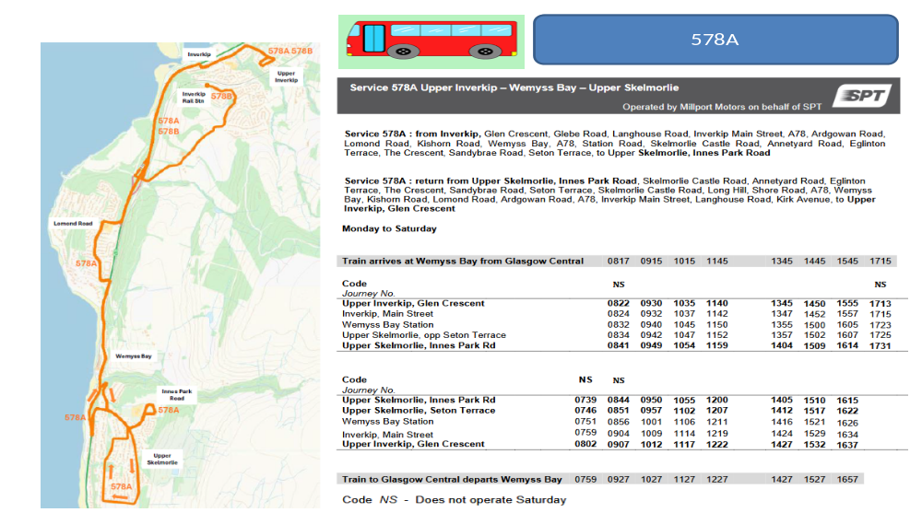

 | Inverkip and Wemyss Bay Community Council list of items for Towns & Villages Funding allocation
 | INVERKIP projects |  | Latest status
1 | Heritage information board replacement. Situated at Daff Glen park on Main Street. The original board had faded and was ripped off in storm couple of years ago. Our CC Andrew Bell has worked with graphic designer and Inverclyde Heritage group to recreate and update the information . We have a design finalised and quote for the work to create and install the board. Costings/quote attached . We have secured some donations to help with the costs from Windfarm Fund, ICE (Inverkip Community Enterprise), and Inverkip Marina . We are looking for £1000 to cover the balance of the costs and the planning permit required. (any excess could be used for other signage relating to local walks or returned to the fund) | 1000 | Sept status: outlook installation end Sept
2 | Bench for Daff Glen park to match the current single bench. (style Lowther to match existing bench) The seating area is popular . Part of Glasdon Quote attached. | 807.64 | Completed INSTALLED 5 May
3 | Planters (including compost & plants) -sited them at Sainsbury's , Nursery, Main Street. We worked with support of Blooming Inverkip in creating and installing some planters which have been very well received by village residents. Blooming Inverkip gardening group is engaged to help maintain the planters. | 300 | Completed
3 | Planters (including compost & plants) - initially propose siting them Inverkip Daff Glen park , Footbridge over A78 entrance Main Street and exit other side at entrance Kip Marina Village. Blooming Inverkip gardening group is engaged to help maintain the planters. | 1500 | Sept status : Awaiting delivery confirmation - outlook end Sept
4 | Friendship bench to be sited at Inverkip School , working with Inverkip school pupils. Multicoloured Bench is to offer space for pupils to sit and encourage socialisation and friendships. Pupils identified a brightly coloured bench for their request. | 464.28 | 4 June : funds transferred to School CONFIRMED
5 | Along with donation towards some new school playground games and eco garden project equipment to encourage team/partner games, and active playing , for both schools. (eg Balls, Tennis equipment ,Bug hotel  Paint to get playground games drawn on the ground ,Tent/ den area  Plastic cushions to sit on,Smaller play equipment eg scoops and balls, skipping ropes, space hopper,etc. ) | 500 | 4 June : funds transferred to School CONFIRMED
6 | 3 new Notice boards . Our wooden notice boards at Cullen Crescent and Glebe Road are deteriorating after +10 years, and suffered damage in the last big storms this season. We aim to replace these two boards, with more robust versions. Plus we are discussing with Sainsbury's and landlord to site a wall mounted additional board there. The notice boards are key part of CC advertising of local events and news relating to villages. | 2024.4 | Sept status : Awaiting delivery confirmation - outlook end Sept
7 | 85th Scouts professional BBQ | 700 | 4 June : funds transferred to Scouts CONFIRMED
 |  | 7296.32
 | Wemyss Bay items identified in discussion with Wemyss Bay Community Association.
 | Project ideas | Totals | Latest status
1 | 3 Picnic tables and 2 benches for beside/behind Wemyss Bay Community Hall. We are hoping Inverclyde Council would help us with ordering and installing them, similar to ones we did at Inverkip Hub years ago. | 3994.71 | Completed INSTALLED 5 May
2 | Notice board at front of WB Community Hall. It did have a notice board, installed similar time as Inverkp ones +10years ago..but was removed/damaged during works and is no longer there. | 634.8 | Sept status : Awaiting delivery confirmation - outlook end Sept
3 | Planters (including compost & plants) - proposed siting them. A new Gardening volunteer group in WB being set up - which hope will work with in creating and maintaining planters | 1500 | 4 June still working on where to site . WB Community Hub not sure if replacing previous planters wanted…as no one was able to maintain them. Ongoing
4 | Donation towards Poly Tunnel (Schools choice rather than bench) to be sited at Wemyss Bay School , | 500 | 4 June : funds transferred to WB Primary School CONFIRMED
5 | Similar to Inverkip Primary - Along with donation towards some new school playground games and eco garden project equipment to encourage team/partner games, and active playing , for both schools. (eg Balls, Tennis equipment ,Bug hotel  Paint to get playground games drawn on the ground ,Tent/ den area  Plastic cushions to sit on,Smaller play equipment eg scoops and balls, skipping ropes, space hopper,etc. ) | 500 | 4 June : funds transferred to WB Primary School CONFIRMED
 |  | 7129.51

